Ideation Phase
Brainstorm & Idea Prioritization
Date | 27/09/2026
Team ID | SWTID-2026-8900
Project Name | Streamlining IT Procurement: Automating Standard Laptop Orders with Flow Designer

Brainstorm & Idea Prioritization:
The main objective of this ideation session is to identify an efficient, automated solution for the IT procurement process, specifically for standard laptop requests. Our team collaborated to brainstorm various approaches to eliminate manual task generation, reduce approval delays, and ensure seamless hardware configuration by leveraging ServiceNow's Flow Designer capabilities.
Reference: https://app.mural.co/t/sreedevikumariwomenscollege2039/m/sreedevikumariwomenscollege2039/1790141394823/93deb4b4af029fc82c9b136425959165f3cb02c2?sender=ubd335d17879cbd7290859004

Step-1: Team Gathering, Collaboration and Select the Problem Statement

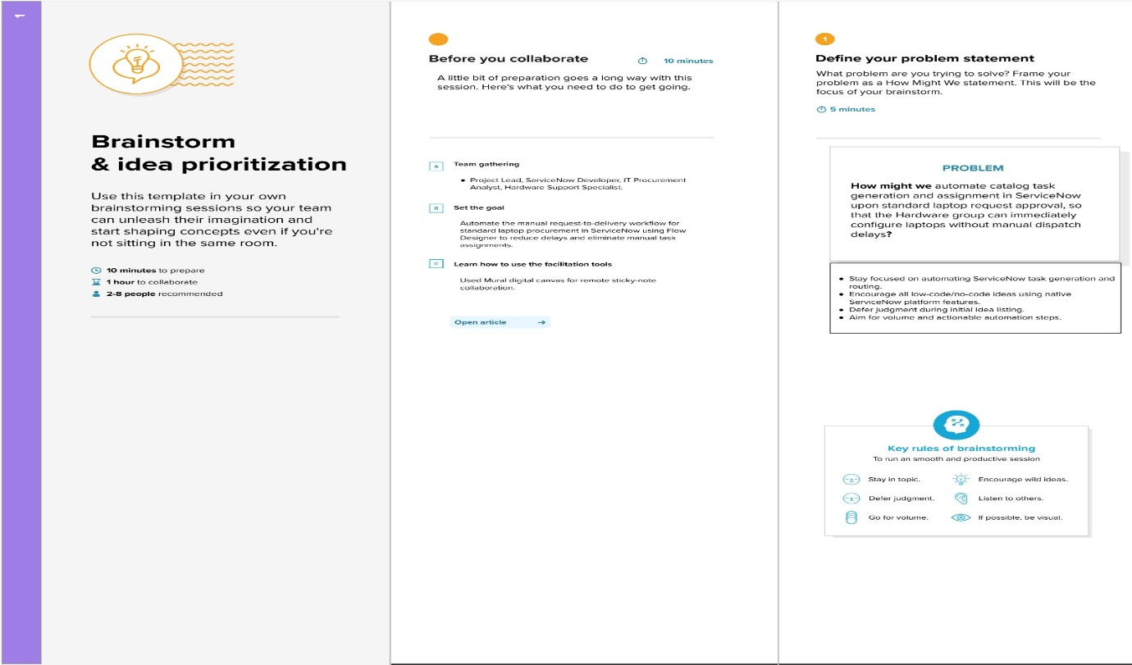

Step-2: Brainstorm, Idea Listing and Grouping

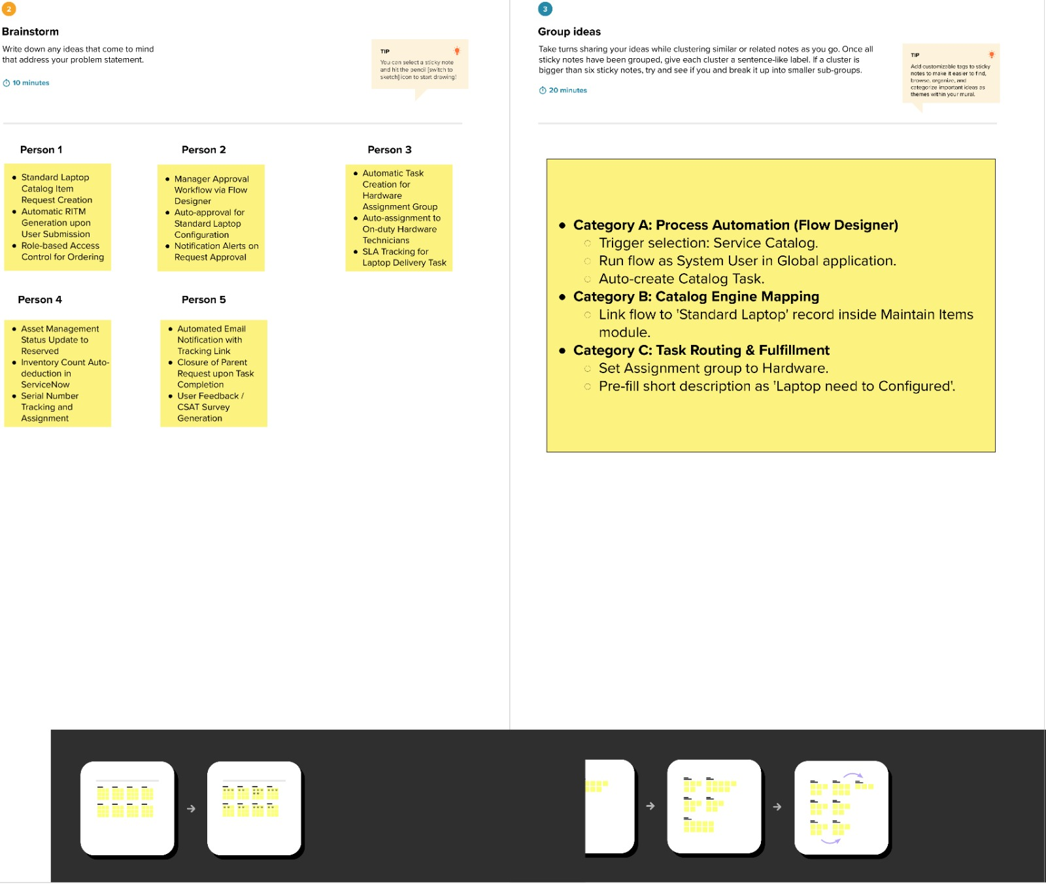

Step-3: Idea Prioritization

